5.5: With the positive y-direction up and the positive x-direction to the right, the free-body diagram of Fig. 5.4(b) will have the forces labeled n and T resolved into x- and y-components, and setting the net force equal to zero,
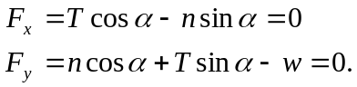
Solving the first for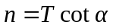 and substituting into the second gives
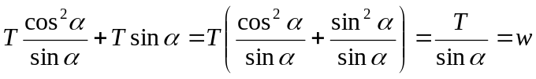

and so as in Example 5.4.

